VIETNAM NATIONAL UNIVERSITY OF HOCHIMINH CITY

THE INTERNATIONAL UNIVERSITY

SCHOOL OF COMPUTER SCIENCE AND ENGINEERING



**THESIS REPORT**

**AN E-LEARNING SYSTEM FOR SUPPORTING STUDENTS**

By

Nguyen Hoang Bao Khanh – ITITIU14045

A thesis submitted to the School of Computer Science and Engineering

in partial fulfillment of the requirements for the degree of   
Bachelor of Information Technology/Computer Science/Computer Engineering

Ho Chi Minh City, Vietnam  
2018

**AN E-LEARNING SYSTEM FOR SUPPORTING STUDENTS**

APPROVED BY: ADVISOR

________________________________ ,   
Nguyen Van Sinh, Ph.D, Chair

THESIS COMMITTEE

# ACKNOWLEGMENTS

It is with deep gratitude and appreciation that I acknowledge the professional guidance of Dr. Nguyen Van Sinh. His motivation, enthusiasm, constant encouragement and support helped me to achieve my goal. During the preparation for thesis, my project as well as report has become more productive and encouraging due to Dr. Nguyen Van Sinh valuale instructions.

I would like to thank my family for their encouragement throughout my undergraduate study in International University and those who supported me to complete the reseach directly or indirectly.

Besides, my gratitude goes to my college friends and teachers who made these years a great learning experience. Especially friends in Computer Science department, they have help me with researching new technology and showing me how to handle difficult in appling those to the thesis project as well as class project. Also, all teacher who were teaching me all the knowlegde through 4 years in International University.

Last but not least, gratitude is also expressed to the members of reading and examination committee.

# TABLE OF CONTENTS

ACKNOWLEGMENTS 3

TABLE OF CONTENTS 4

LIST OF FIGURES 6

LIST OF TABLES 7

ABSTRACT 8

CHAPTER 1 9

INTRODUCTION 9

1.1. Background 9

1.2. Problem Statement 9

1.3. Scope and Objectives 9

1.4. Assumption and Solution 10

1.5. Structure of thesis 10

CHAPTER 2 12

RELATED WORK 12

2.1. Technology Used 12

2.1.1. NodeJS 12

2.1.2. ExpressJS 12

2.1.3. MongoDB 12

2.2. Existing services using E-learning system. 13

2.2.1 Online learning support. (Chegg) 13

2.2.2 Elearning: Advices about learning English. 14

2.2.3 Elearning Center Page. 16

CHAPTER 3 20

METHODOLOGY 20

3.1. Overview 20

3.2. Use Case Diagram 20

3.3. Activity Diagram 25

3.4. Database Structure 26

CHAPTER 4 27

IMPLEMENT AND RESULTS 27

4.1. Implement 27

4.1.1. Visual Studio Code 27

4.1.2. NodeJS 27

4.1.3. NodeJS Package 31

4.1.4. MongoDB 31

4.2. Results 34

4.2.1. Streaming 1-many. 34

4.2.2. Push New Notifications 35

4.2.3 Chat 37

CHAPTER 5 39

CONCLUSION AND FUTURE WORK 39

5.1. Conclusion 39

5.2. Future Work 39

REFERENCES 40

# LIST OF FIGURES

*Figure 1 – Event-loop mechanism*

*Figure 2 – Chegg*

*Figure 3 – Discuss Forum*

*Figure 4 – Online Course Register*

*Figure 5 – Online Consultant registration*

*Figure 6 – Online Quiz*

*Figure 7 – Update news*

*Figure 8 – Online Support*

*Figure 9 – Online Course Register*

*Figure 10 – Opening Schedule*

*Figure 11 – Learning Schedule*

*Figure 12 – Exam Information*

*Figure 13 – System Architecture*

*Figure 14 – Use Case Diagram*

*Figure 15 – Activity Diagram*

*Figure 16 – Entity-Relationship Diagram*

*Figure 17 – Visual Studio Code*

*Figure 18 – NodeJS*

*Figure 19 – Introduction Installation of NodeJS*

*Figure 20 – License Agreement*

*Figure 21 – Destination Select*

*Figure 22 – Installation Type*

*Figure 23 – Summary*

*Figure 24 – Checking the Installation*

*Figure 25 – NodeJS Package*

*Figure 26 – Homebrew*

*Figure 27 – Installation of Homebrew*

*Figure 28 – Installation of Mongodb*

*Figure 29 – Run Mongodb*

*Figure 30 – Testing Mongodb*

*Figure 31 – Live Stream*

*Figure 32 – Teacher and Student Interface*

*Figure 33 – Register Interface*

*Figure 34 – View Class list*

*Figure 35 – Class Available*

*Figure 36 – List Of Student*

*Figure 37 – Student Interface*

*Figure 38 – User interfaces*

*Figure 39 – Socket new message*

# LIST OF TABLES

*Table 1 – Use Case 1: Login/Logout*

*Table 2 – Use Case 2: Course Registration*

*Table 3 – Use Case 3: Add course*

*Table 4 – Use Case 4: Edit Cours*

*Table 5 – Use Case 5: Start Lecture*

*Table 6 – Use Case 6: View List of Students*

*Table 7 – Use Case 7: Register*

*Table 8 – Use Case 8: Join Lecture*

*Table 9 – Use Case 9: Manage Users*

# ABSTRACT

The education is growing by developing many new reforms in recent years. One of those development is gradually transforming the traditional way of learning into online learning. There are lots of website that applied online learning into their system and gradually replaced the previous kind of learning. Online learning help student to explore more knowledge in their free time and dig deeper while finding new sciolism. This kind of learning can also help students to save more time, online learning does not required students to go to some specific place to study, they can stay at home and learn online through Internet. To manipulate the convenient of this kind of system, in this thesis, I would to research and create a web-application that can help students in learning. Therefore, I will make a live streaming for student to learn directly, not watching the recorded video on website. This system will be called “An e-learning system for supporting students” which will help students save time in learning new knowledge and can direct consult from teacher.

# CHAPTER 1

# INTRODUCTION

## Background

In order to catch up with new advances technology in web development, I decided to use NodeJs to implement back-end, AngularJs for front-end and using MongoDB as NoSql database to increase the speed of website as well as real-time communication between client and server. There are courses that help me to fulfill those requirements such as: Web Application Development, Object-Oriented Programming, Principles of Database Management, etc.

In **Object-Oriented Programming** course helps me with thinking in new way of creating inherited class for multiple purposes such as querying data from NoSql database to use in the project and how the inheritance or others attribute of OOP work in class-based object-oriented languages.

Furthermore, **Principles of Database Management** only teaching me how to develop database, but database is also an important thing to notice in web development. If the developer did not design a database that can be maintained in the future in case the user wants to evolve the business, then the developer must re-design the database and sometime may affect the project which will cause some risk.

To sum up all the knowledge from above course and other courses, I used it in course **Web Application Development** to develop a full functional website for ecommerce, selling product online or emulating the library for student to buy or borrow books.

Moreover, I want to develop a system for student to learn online via Internet and study live with real-time communication but not uploading the course on website and student will view when they have free time.

## Problem Statement

The traditional way of learning is used until the new way which is online learning becoming new trend of learning these day. There are several advantages and disadvantages of online learning way compare to the traditional way.

First, the traditional way of learning is being used by every school very long time ago and it would cause some problems like: student must go to the hall to study although outside is raining heavily or being sicked and can not go anywhere, etc. These problems will lead to missing some important lecture involved in the final exam or quick test. But, students can have a chance to discuss with teacher after the lesson or during break time. Moreover, going to class can helps student to expand their relationships with other students as well as teacher.

Second, online learning is able to solve the problem of staying at home but still able to catch up with new lesson. But, the online learning platform nowsaday is only focusing on showing users the recorded video without having communication with the learners or teacher can answer student’s question through comments in that lecture.

Finally, this project is about creating an online learning for student to interact with teacher when the lesson is live on the Internet and teacher can teach the lesson as well as answer the question of student during the lecture.

## Scope and Objectives

This project will consist of creating an application for any type of platform which used teacher and student model such as school, teaching center, etc. For any of the model above, they have the same type of user: staff, teacher, student. Each type above has their own function in the system. For staff, they can create class based on existed list of course in the database for teacher to manage their class. Teacher main function is announcing the time when they start their lesson and live stream as 1-many to the user. Last is student, they can regist for course to study, notice new notification as soon as teacher post to all student in the class and join the lesson when teacher begin their live.

## Assumption and Solution

There are lots of limitation in order to complete the full project of supporting student in studying online. Until now, I encountered some problems such as: how to apply new technology and time limitation.

First, in the beginning of the project, I must reseach and test for applying live streaming in several languge but the most suitable one is NodeJS because it supports more on client-server scripting compare to other languages. Furthermore, NodeJS applications mostly use **Single Threaded Event Loop Mode** architecture to handle multiple concurrence clients and it is an asynchronous operation. For example, the below code snippet shows how the Event-loop mechanism function:

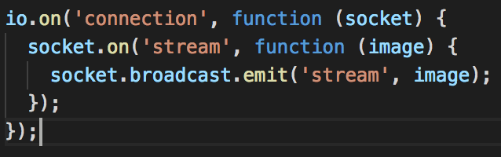

*Figure 1 - Event-loop mechanism*

When client activated “**connection**” event on client side by clicking on button or some similar, server will fire this event  which the loop picks up and immediately publishes to the thread pool and is ready to receive the next request and this is the main functionality differentiation between NodeJs based servers and other IIS/ Apache based servers. NodeJs for every connection request do not make a new thread instead it gets all request on single thread and delegates it to be handled by numerous server side to do the required task.

Second is the time, this is just a demo of some function will be included in the project because I can not complete all the function of this project in time. More functions will be developed in the future and the complete project will finish as soon as possible.

## Structure of thesis

The thesis structure will include 6 chapter: Introduction, related work, methodology, implement and result, discussion and evalutation, conclusion and future work.

In chapter 1, I will introduce some background knowledge to help me with this project, some advantages and disadvantages of the traditional learning method and online learning system. Those part is mainly about previous knowledge after going in to coding the project. The remaining is about designing model for this project and some difficult might encounter while doing.

In chapter 2, it is mainly about all technique which is available in this project and the researching the market before designing or going into work. How to apply these existed technologies in to the project, which system is already published in the market before and analyze all the software, advantage, disadvantage of those system.

In chapter 3, mainly about diagrams of the app such as Use Case Diagram, Activity Diagram and also include the way to apply methods and techniques mentioned in chapter 2.

In chapter 4, how to implement thost relevant technical in this project and some picture to show the beta version of how this app will be structured when completing all the work.

In chapter 5, the final chapter will metion about my experiences and some lesson learned after the project is completed. Most important part is the future work to improve the application more effective.

# CHAPTER 2

# RELATED WORK

## Technology Used

In chapter 2, I would like to review all the technology that I used to build the E-learning platform and some existed service on the market.

New languages are using data in the form of JSON due to it readability. JSON (JavaScript Object Notation) is a lightweight data-interchange format. It is easy for humans to read and write. It is easy for machines to parse and generate. JSON is a text format that is completely language independent but uses conventions that are familiar to programmers of the C-family of languages, including NodeJS, Perl, Python, and many others. These properties make JSON an ideal data-interchange language.

In this project, I will use several language and database which is familiar in using JSON as well as query JSON document as NoSQL database program like NodeJS for dealing with back-end, AngularJS for handling API data from server push to client and MongoDB for saving data as JSON format and query time is faster when combining NodeJS query.

### NodeJS

NodeJS is an open-source, cross-platform JavaScript run-time environment that executes JavaScript code server-side. It was first written in 2009 by Ryan Dahl after the introduction of the fisrt sever-side JavaScript environment, Netscape's LiveWire Pro Web. He was desired an easier way to handle file upload progress bar on Flickr after seeing the browser did not know how much of the file had been uploaded and had to query the Web server. In 2008, NodeJS combine with Google's V8 JavaScript engine, an event loop, and a low-level I/O API.

NodeJS package was introduced to NodeJS in 2010, npm, is the most advantages in this project due to it ecosystem which is considered as the largest ecosystem of open-source libraries in the world. NPM designed to simplify installation, updating, and uninstallation of libraries.

Node.js is an asynchronous event-driven, non-blocking I/O model that makes it lightweight and efficient. Every single event clicked by user will fire the connection to server-side, NodeJS will work during the connection is fired otherwise NodeJS will sleep.

### ExpressJS

There are several frameworks that Node supports but I choose Express to be this project frameworks. Express is a web application framework for Node.js, released as free and open-source software under the MIT License which is designed for building API.

The original author was TJ Holowaychuk who described Express as Sinatra-inspired server. Express is the backend part of the MEAN stack, together with MongoDB database and AngularJS frontend framework.

### MongoDB

MongoDB is a NoSQL database which uses JSON like documents with schemas, MongoDB is also a free and open-source cross-platform document-oriented database program. Moreover, there are lots of features that MongoDB support such as: queries, indexing, replication, load balancing, server-side javascript execution.

## Existing services using E-learning system.

Online learning is not a hot trend anymore because there are lots of learning page existed on the market before. I will introduce three pages which has the same function for supporting student in learning online.

### Online learning support. (Chegg)

* Website Reference: https://www.chegg.com/
* Functions:
  + Online tutoring: Student can choose: rent or buy books, find textbook solutions, ask a study question.

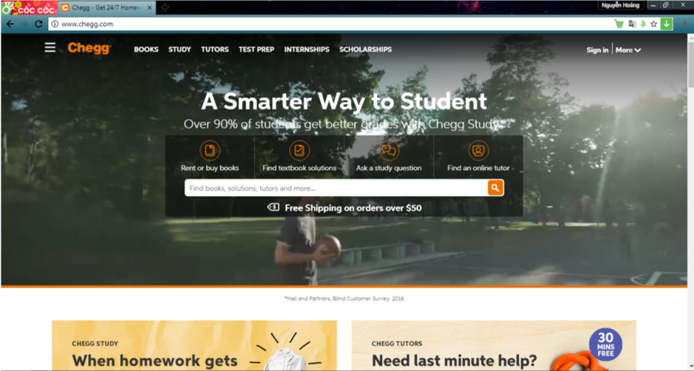

*Figure 2 – chegg*

* + Forum to discuss question with other student: Student can post their question and others who knows the answer can help.

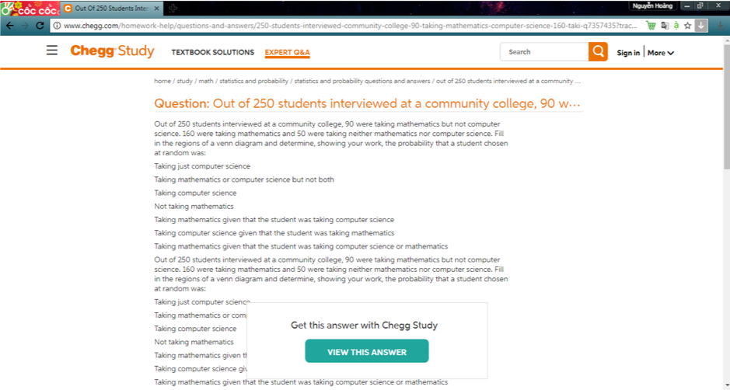

*Figure 3 – Discuss Forum*

* Algorithms:
  + Client-Server.
* Advantages:
  + Student can learn with the best teacher in different college.
  + Get instant help when needed (no need to fill out forms, download any applications and software, or go through a series of phone calls)
  + More flexibility during the school week.
  + Many teachers in different fields to choose.
* Disadvantages:
  + Have to pay an amount of fee to chat with tutors.
  + Not include video chat directly to student only messenger.

### Elearning: Advices about learning English.

* Website Reference: http://mshoagiaotiep.com/
* Functions:
* Online Course Register: User can request a schedule for checking knowledge about course that they want to study.

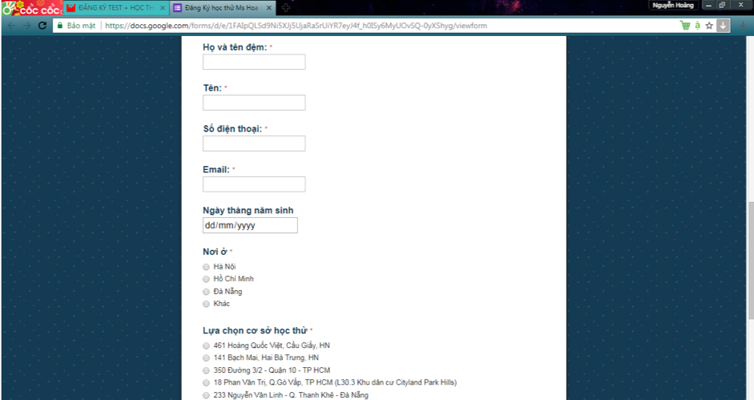

*Figure 4 - Online Course Register*

* Online Consultant registration: Filled out the form so that consultant on mshoagiaotiep.com can contact back and answer question that user filled in.

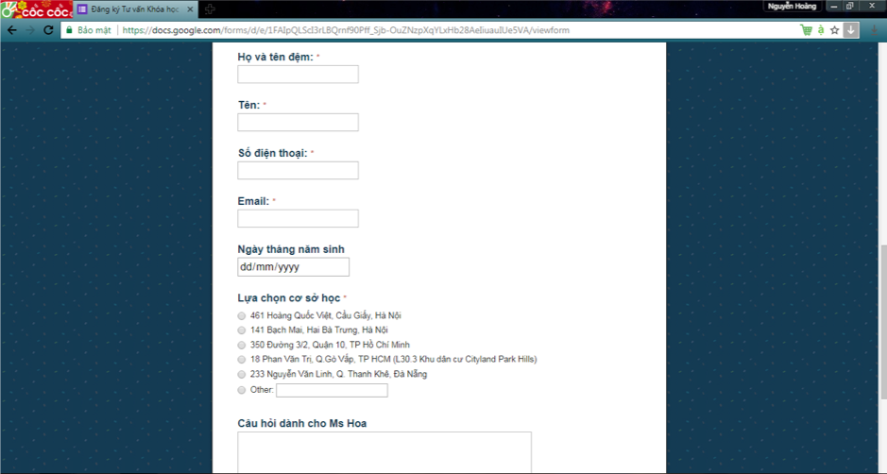

*Figure 5 - Online Consultant registration*

* Tutorials
* Take online quiz: There are multiple quizzes/practises for student can choose and learn in advantage.

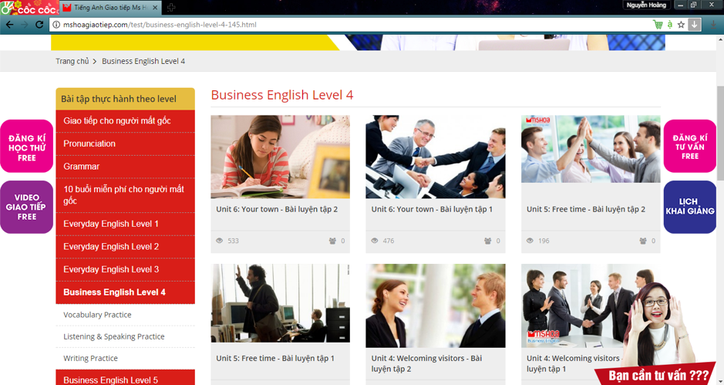

*Figure 6 – Online Quiz*

* Update news: News about class or English information will be post on main page of website.

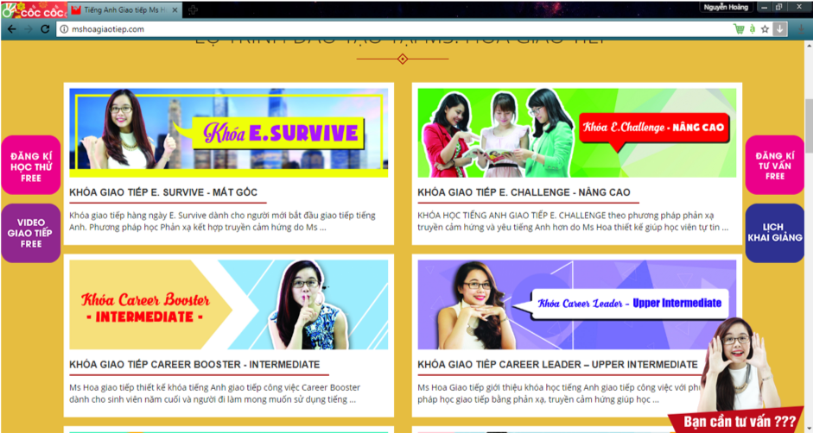

*Figure 7 – Update news*

* Algorithms:
  + - Facebook messenger.
* Advantages:
  + - Register online and then get help when consultant contact back via phone.
    - Take quiz and tutorial online to check knowledge.
* Disadvanteges:
  + - Not include video chat.
    - Online support just for comment on facebook and then consultant will reply back (not direct chat).

### Elearning Center Page.

* Website Reference: http://elc.ehou.edu.vn/
* Function:
  + Online Support via skype or phone: There are phone or button to connect skype for user to choose and make contact with consultant on http://elc.ehou.edu.vn website.

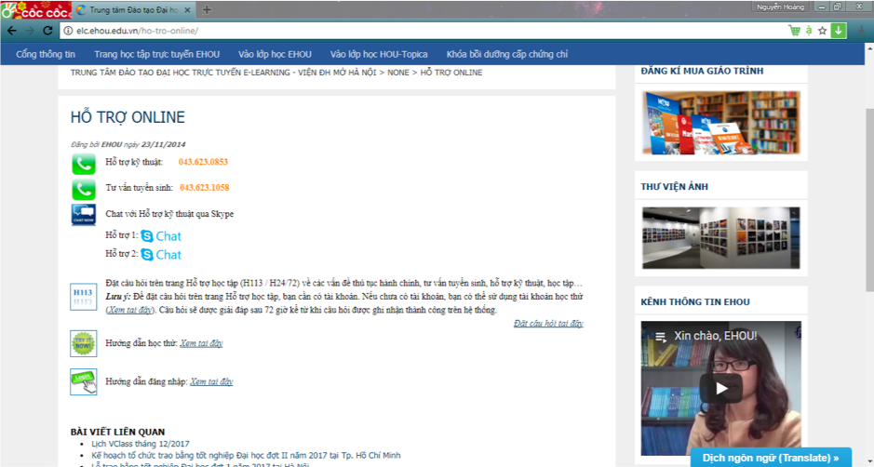

*Figure 8 - Online Support*

* + Online Course Register: User can field their information about subject they wanted to study, etc so that consultant can base on that information and select course or contact back for more information.

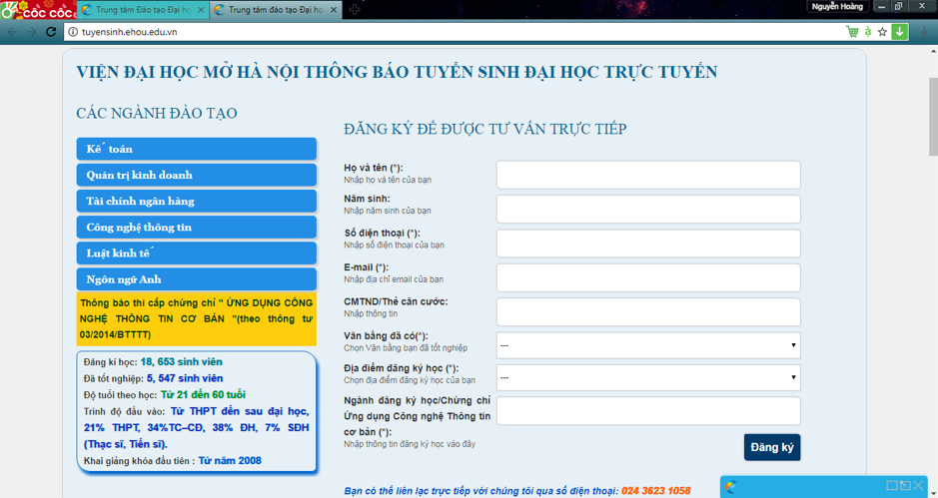

*Figure 9 - Online Course Register*

* + Schedule: Opening, Exam schedule.
    - Opening Schedule: Student who registered can check online for opening course.

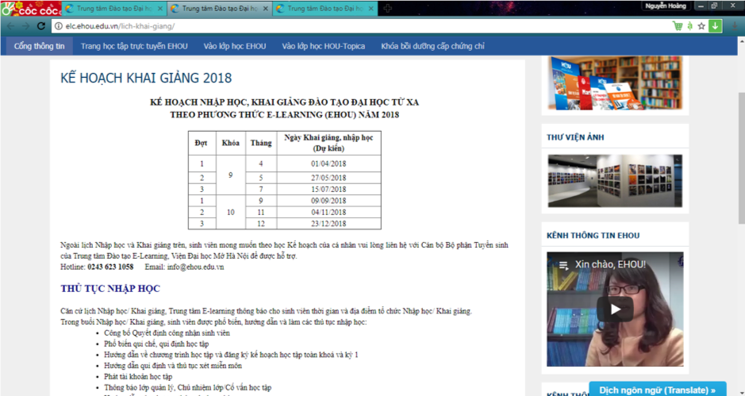

*Figure 10 - Opening Schedule*

* + - Learning Schedule: Full information about learning schedule on each class or subject to make student can check easier.

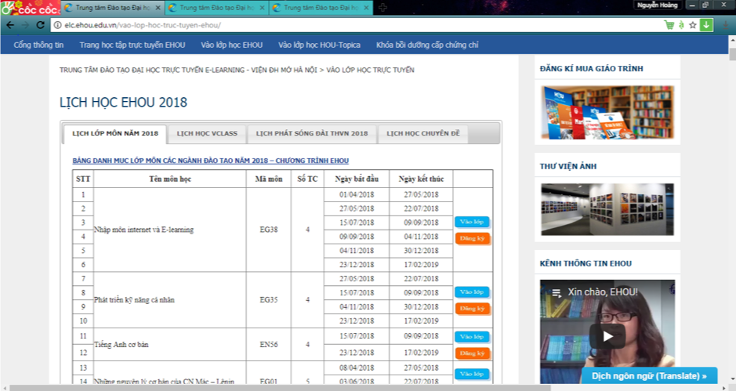

*Figure 11 - Learning Schedule*

* + - Exam Information: School will post information about exam on each class.

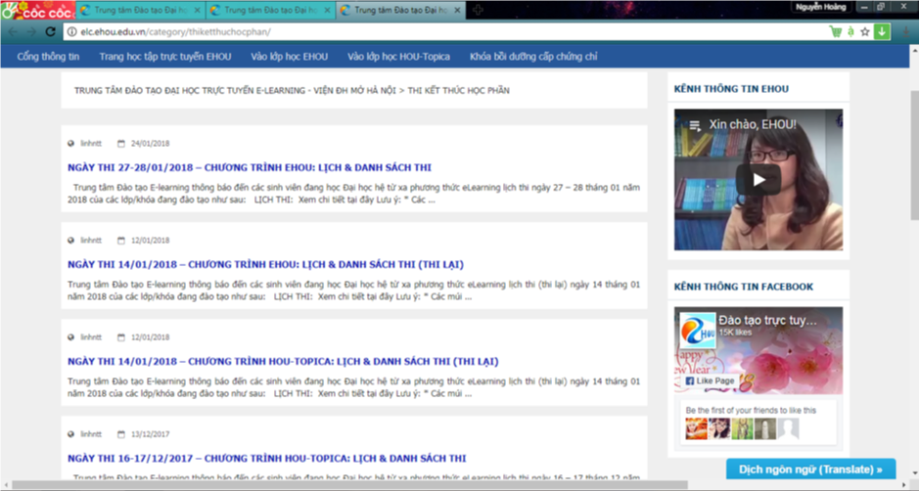

*Figure 12 - Exam Information*

* + - Tutorials.
* Algorithms:
* Advantages:
  + Student can regist online and consultant will base on student’s information to call for help later if they need.
  + Student can check schedule and news online instead of going to notice board on campus.
* Disadvantages:
  + Does not support online chat on website.

# CHAPTER 3

# METHODOLOGY

This chapter will introduce all the method that being used to build and some diagrams about Database, UI, etc.

## Overview

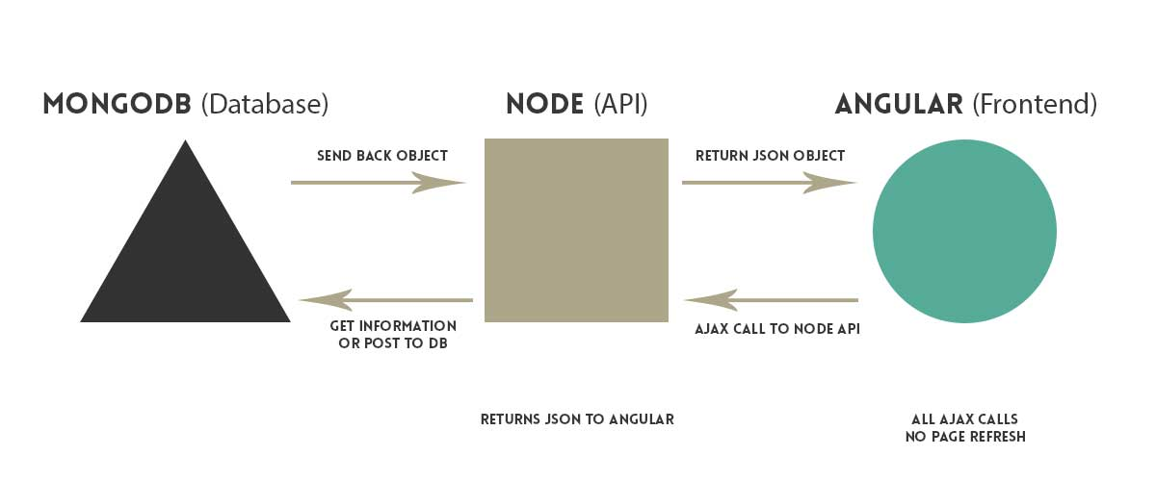

*Figure 13 – System Architecture*

The Figure shows data is being transferred between MongoDB Database and AngularJS (Client Side). When users call some function required to access to database, AngularJS will call NodeJS (Server side) API and NodeJS will post/get/delete/update to Database. When MongoDB received the signal from NodeJS, it will send back to node an Object holding the information that Client requested and NodeJS will transfer that information to Angular in JSON format to display or do anything user request at the beginning.

## Use Case Diagram

The figure 14 shows the basic function that actor (student, teacher, staff) can do in an e-learning system.



*Figure 14 – Use Case Diagram*

Description of use cases:

*Table 1 – Use Case 1: Login/Logout*

|  |  |
| --- | --- |
| **Name** | **UC-1: Login/Logout** |
| Summary | Access permission to the system of users. |
| Rationale | All the users including staffs, lecturers and students need to login to use the functions of the system. Then they need to logout of their accounts to make sure that their information won’t be leaked. |
| Users | Staffs, lecturers and students |
| Preconditions | Users must have their correct information (username and password) to access the system. |
| Basic Course of Events | 1. User goes to system site.  2. User inputs username and password then click Enter.  3. System will check the information and grant access  permission if the information is valid. Otherwise, it will  display error message to user interface.  4. User inputs information again if they have entered wrong  information.  5. User logins to the system and do the system’s functions. |
| Alternative Paths | If the user doesn’t do step 2 or step 4, they just can read the news of the university. |
| Postconditions | User gets access to the dashboard and can do the fuctions that system provides. |

*Table 2 – Use Case 2: Course Registration*

|  |  |
| --- | --- |
| **Name** | **UC-2: Course Registration** |
| Summary | Regist new course for new semester. |
| Rationale | Every new semester require student to regist course in order to learn. The course registration function allows student to regis new course and sever will save the course until the end of semester. |
| Users | Student |
| Preconditions | A list of course is loaded. |
| Basic Course of Events | 1. User request for a list of course related to their field of study.  2. Software return a list related to user information.  3. User search for course that they want to learn in a limit of  credit (from 12 to 24).  4. User click on “Save”.  5. Software save user choice into database. |
| Alternative Paths | User may decide to abort the registration course during step 1,2 or 3. Software will return to Preconditions stage. |
| Postconditions | Software save the selected course by student in database. |

*Table 3 – Use Case 3: Add course*

|  |  |
| --- | --- |
| **Name** | **UC-3: Add Course** |
| Summary | Add more course to achieve full credit in one semester. |
| Rationale | Student may want to study more in one semester so that they can graduate on time. |
| Users | Staff. |
| Preconditions | List of course. |
| Basic Course of Events | 1. User request for a list of course related to their field of study. 2. User find course they want to study and tick to the box next to course name. 3. User click “Save”. 4. Software save user choice to database. |
| Alternative Paths | None |
| Postconditions | New course in the list of course. |

*Table 4 – Use Case 4: Edit Course*

|  |  |
| --- | --- |
| **Name** | **UC-4: Edit course** |
| Summary | Change the name of course, lecturer who teach this course, start time and finish time, cost for this course. |
| Rationale | This function support for staff when they have made some mistake while typing, so they can correct the mistake later. |
| Users | Staff |
| Preconditions | User login with staff account and course already add to database. |
| Basic Course of Events | * + - 1. Staff click on edit button       2. Then type the correct information for this course  1. Click on “Done” button to finish this task |
| Alternative Paths | 1.   In step 3, instead click “Done” button, staff can click “Cancel” button to cancel on process from step 1 to2. Database has not been changed. |
| Postconditions | Information have been changed in database. |

*Table 5 - Use Case 5: Start Lecture*

|  |  |
| --- | --- |
| **Name** | **UC-5: Start Lecture** |
| Summary | Teacher can start the lecture when he wanted |
| Rationale | Each course has starting time so that student can join in and learn, teacher can start the lecture. |
| Users | Teacher |
| Preconditions | User login with teacher account. |
| Basic Course of Events | 1.      1. Click to the class which reached study time.  2.      2. Press “Start” to begin live stream. |
| Alternative Paths | 1.   None |
| Postconditions | The camera begins to capture. |

*Table 6 – Use Case 6: View List of Students*

|  |  |
| --- | --- |
| **Name** | **UC-6: View list of Students.** |
| Summary | Teacher can know which class contained how many students in that class by viewing the list of students. |
| Rationale | There is different course that teacher can teach so list of students for teacher to know which student in which class. |
| Users | Teacher. |
| Preconditions | User login with teacher account. List of class has been loaded. |
| Basic Course of Events | Click on ‘View Class list’. |
| Alternative Paths | None. |
| Postconditions | None. |

*Table 7 – Use Case 7: Register*

|  |  |
| --- | --- |
| **Name** | **UC-7: Register.** |
| Summary | Student can register new account to learn. |
| Rationale | When user find some courses that they wanted to learn, register for an account is the first step after viewing those courses. |
| Users | User. |
| Preconditions | None. |
| Basic Course of Events | 1. Click on “Register” button.  2. Input user information.  3. Click “Done” button to finish this task. |
| Alternative Paths | If some informations are not correct, then when user press “Done” it is not going to save to database, user must input again to correct it. |
| Postconditions | New user created. |

*Table 8 – Use Case 8: Join Lecture*

|  |  |
| --- | --- |
| **Name** | **UC-8: Join Lecture** |
| Summary | When the lesson started, student can join whenever he wants to learn. |
| Rationale | When student login to this system, the list of registered class of Student will be shown and student will choose which class to view the live stream. |
| Users | Student. |
| Preconditions | User login with student account. List of class page loaded. |
| Basic Course of Events | Click on “Watch” button. |
| Alternative Paths | None. |
| Postconditions | Class page loaded. |

*Table 9 – Use Case 9: Manage Users*

|  |  |
| --- | --- |
| **Name** | **UC-9: Manage Users** |
| Summary | Create account for Student and Lecturer.  Update necessary information for these user (Course, tuition fees) |
| Rationale | When the student login to our website to registration course or lecturer want to know information of course that they have to teach (room, time, student). In addition, staff ability to confirm about tuition fees. |
| Users | Staff |
| Preconditions | User login with staff account. Manage user page have been loaded. |
| Basic Course of Events | 1.      Click on ‘Create account’  2.      Input information for this account (username, password, role[student/lecturer/staff])  3.      Click “Done” button to finish this task |
| Alternative Paths | 1.      Instead click on “Create account”, we can click on “Update User” button to change user information. The do the same step 2 and 3 above.  2.      In step 1, we can click on button “Remove” to remove this user account. |
| Postconditions | Database changed. |

## Activity Diagram



*Figure 15 – Activity Diagram*

The figure 15 is the activity diagram of my application project. When ever user Login into the system, it will check for the existence of that user in database. If login with correct information in database so user can continue to do with their own function (Eg: student can register course, watch stream. Teacher can live stream, view student list, Staff can create/add/edit new course to database or create class). And if the account is not existes so user can register for a new account and relogin.

## Database Structure



*Figure 16 – Entity-Relationship Diagram*

The database of this application included four tables. First table is “**user**” which has the function of saving user information like name, id, email, etc. “**course**” is the seconde table, save all course information. Third table is “**lists**”, this is a middle table to save information of course and user with their id only, by using this each course contain different user list. The last table is “**classes**” which included all the information of a class like coursecode, coursename, etc. Each table have it own relationship, like “**user**” and “**classes**” is 1-to-many because 1 user can have many classes. Between “**user**” and “**lists**” is also 1-to-many because 1 user can be in many lists. The last relationship 1-to-1 which is different from others because 1 course can only be in 1 lists (list of course is very limit not as many as classes due to 1 course can have many class).

# CHAPTER 4

# IMPLEMENT AND RESULTS

* 1. **Implement**
     1. **Visual Studio Code**

Visual Studio is a code editor which I choosed to implement this project due to its convenient ability. Visual Studio Code is redefined and optimized for building and debugging modern web and cloud applications. In order to use it, first go to <https://code.visualstudio.com> and choose the version which suitable with your platform: MacOs, Windown or Linux.

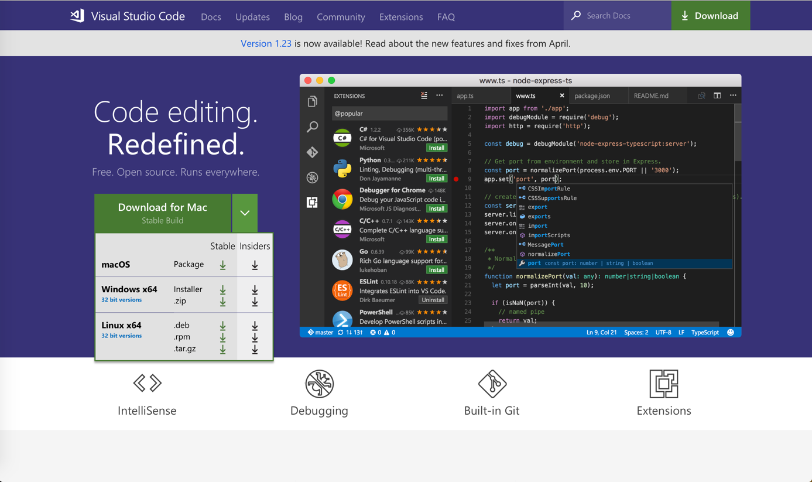

*Figure 17 – Visual Studio Code*

After downloading the software, it will install automatically into your machine.

* + 1. **NodeJS**

Fisrt, go to <https://nodejs.org/en/> and select the version for downloading. In my project, it is 8.11.2 LTS version because the newest version may not stayble for using.

After hitting download button, the software will be in your Download folder and should be ready to install when finishing downloading. Double Click on the downloaded software to install NodeJS to your computer.

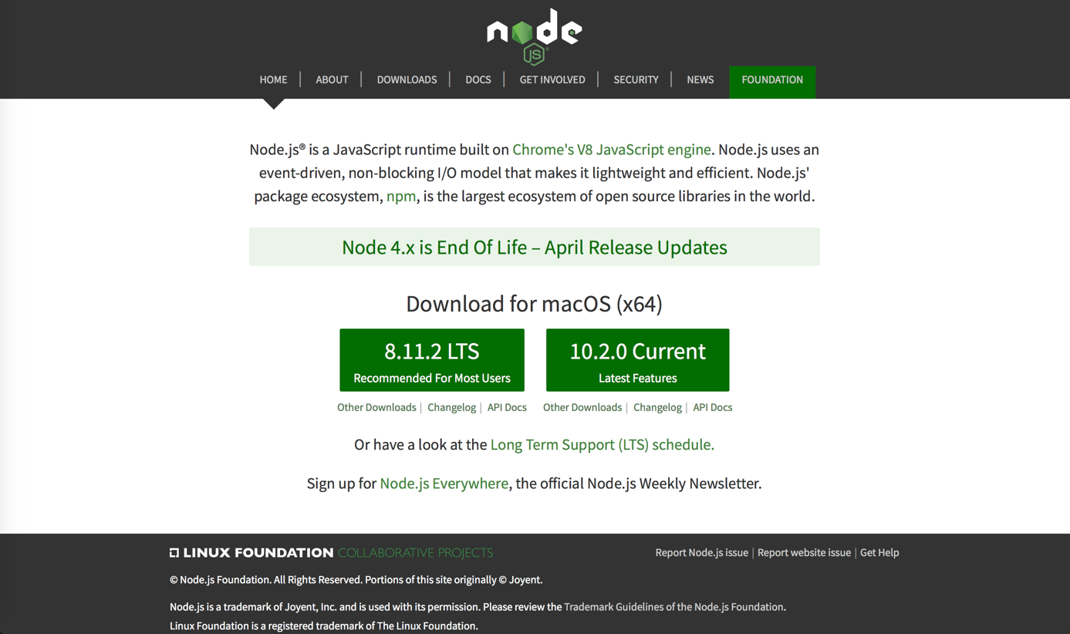

*Figure 18 – NodeJS*

The installation of NodeJS is started. Press Continue to go to License part.

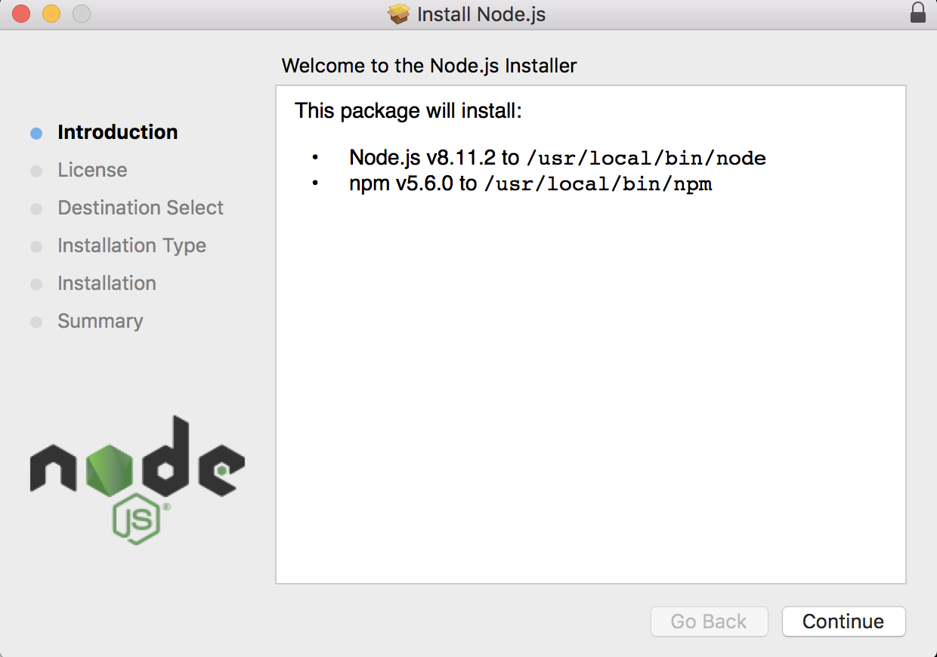

*Figure 19 – Introduction Installation of NodeJS*

Agree to the License in order to continue the installation of NodeJS.

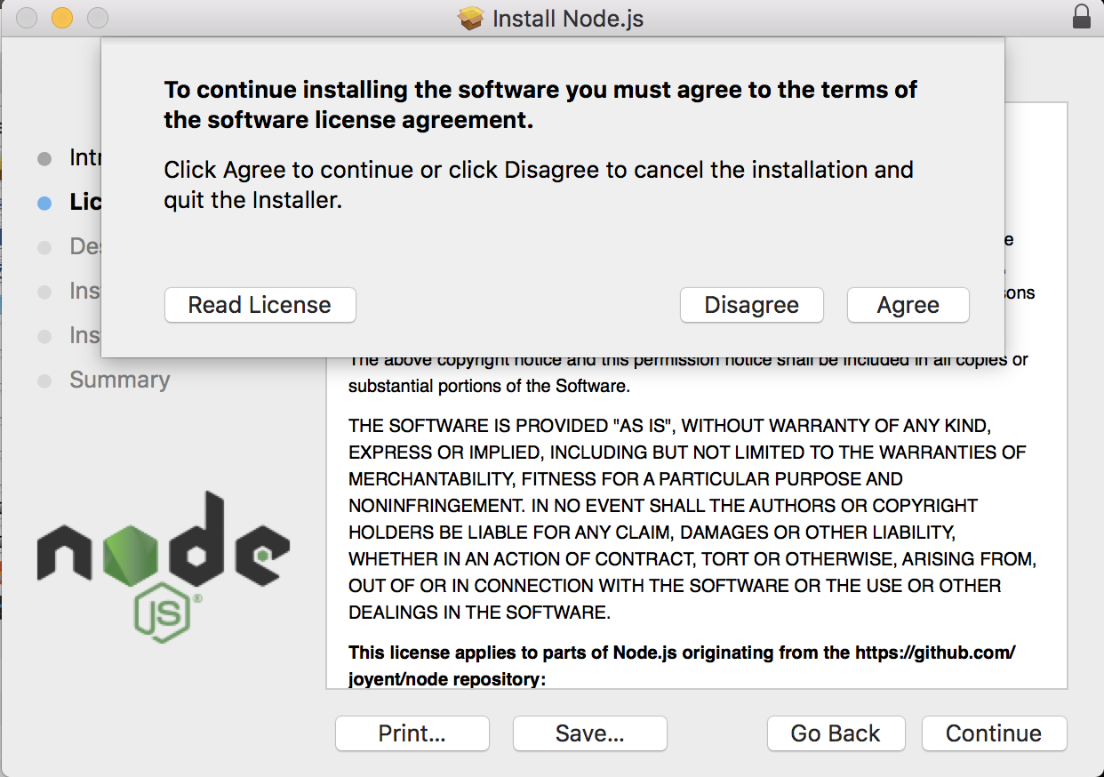

*Figure 20 – License Agreement*

Next step is choosing the folder to install.

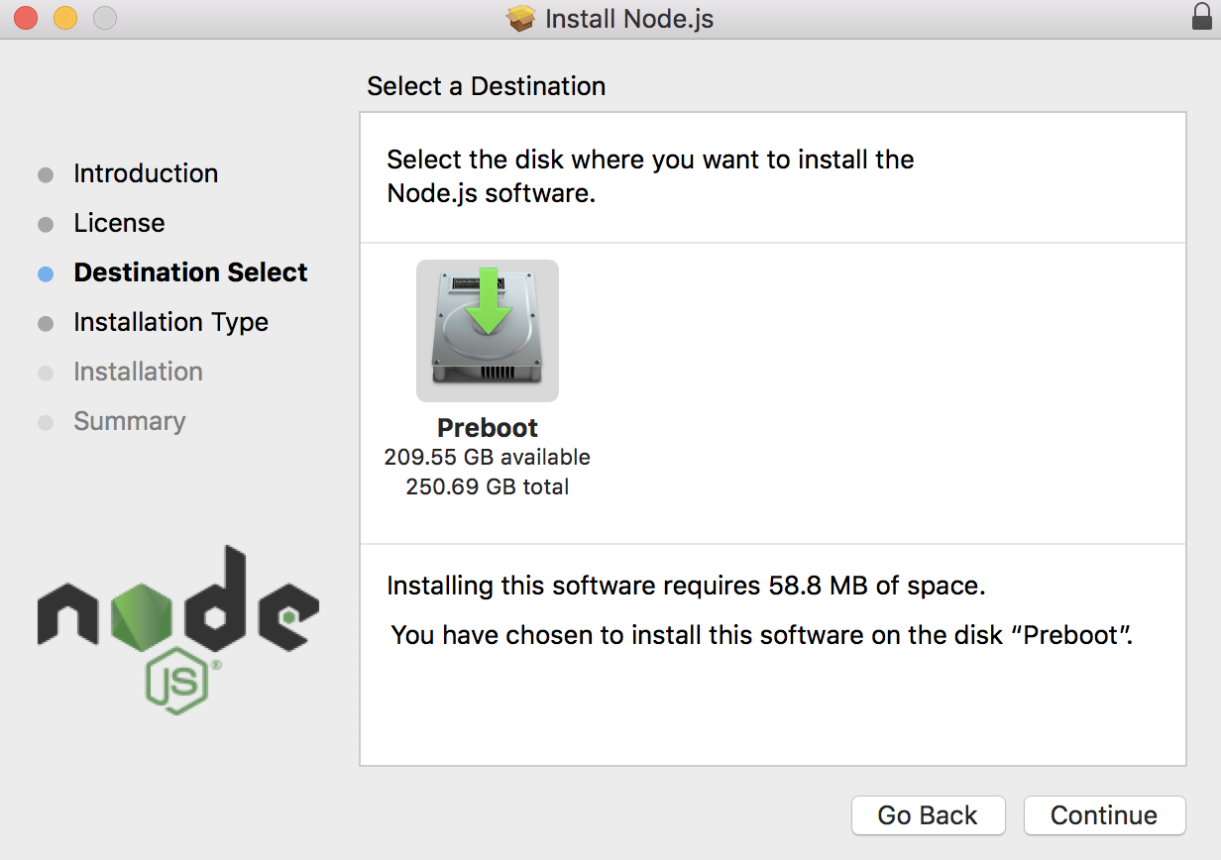

*Figure 21 – Destination Select*

After that, press continue and install to start the install process.

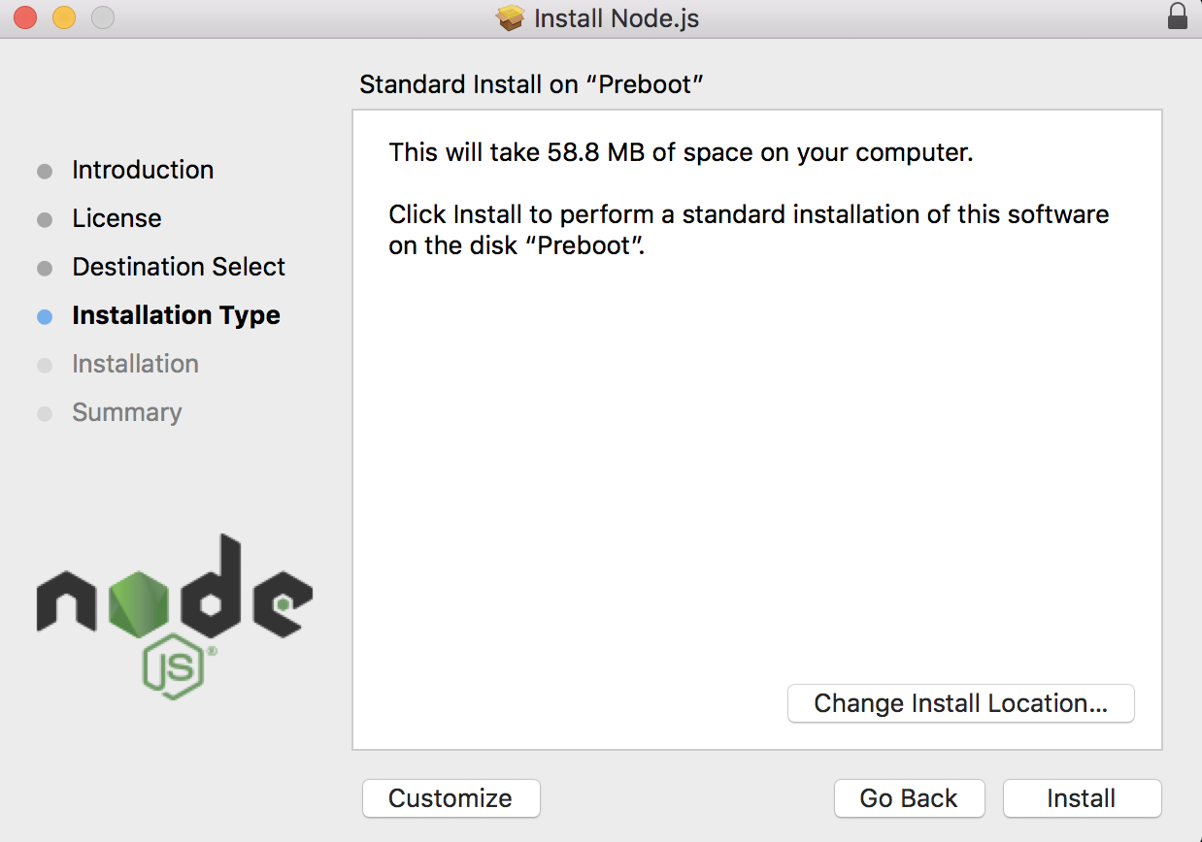

*Figure 22 – Installation Type*

The installation is quickly so the Summary part will show what you have just installed in your computer.

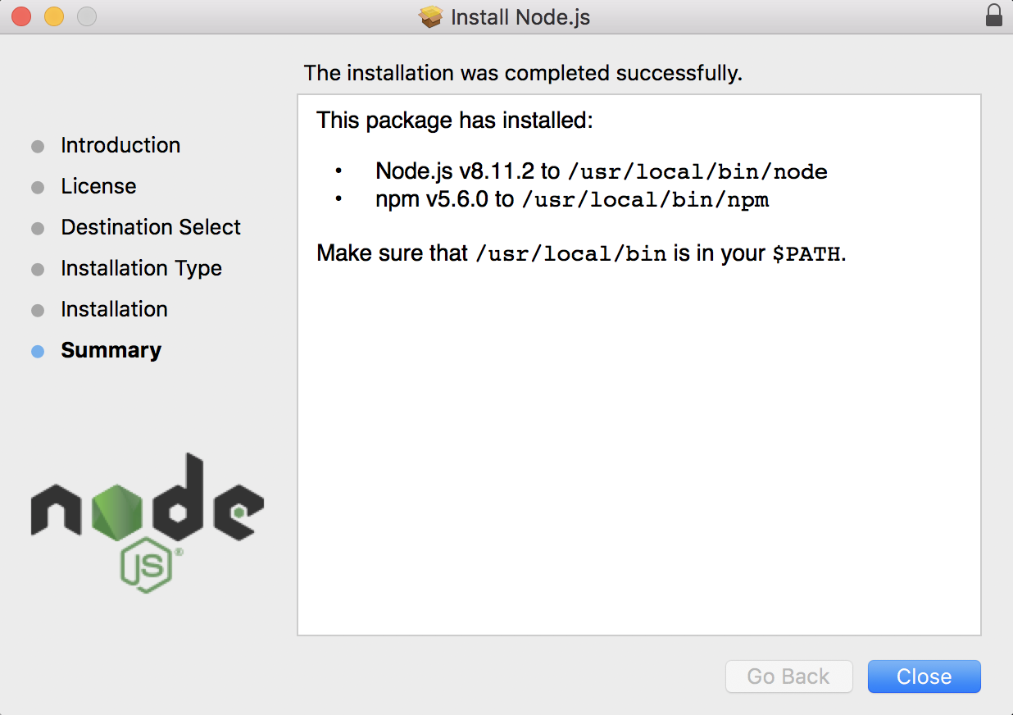

*Figure 23 – Summary*

Last step is to check whether you are installing NodeJS or not by opening the terminal and type node –version. If the terminal line shows like which means NodeJS has been installed successfully.

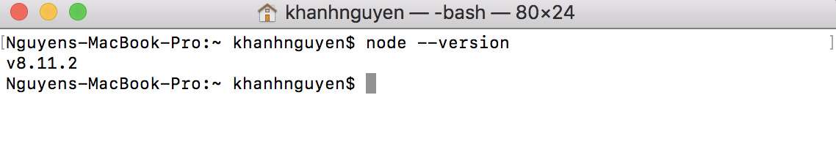

*Figure 24 – Checking the Installation*

* + 1. **NodeJS Package**

There are lots of package to support the project to run smoothly and those packages will help with the implementation. User can go to <https://www.npmjs.com> to explore more about package and how to use or install it. The basic command to install one package is “npm install <package name>”.

If the user wants to install as global so in others project may not have to install again then type “npm install -g <package name>”.

If the users only want to install the package for this project only so type “npm install --save <package name>”.

All the package after installing will be in package.json file and saved like the picture below. Dependencies category is all the package that programmer wants to use for the project.

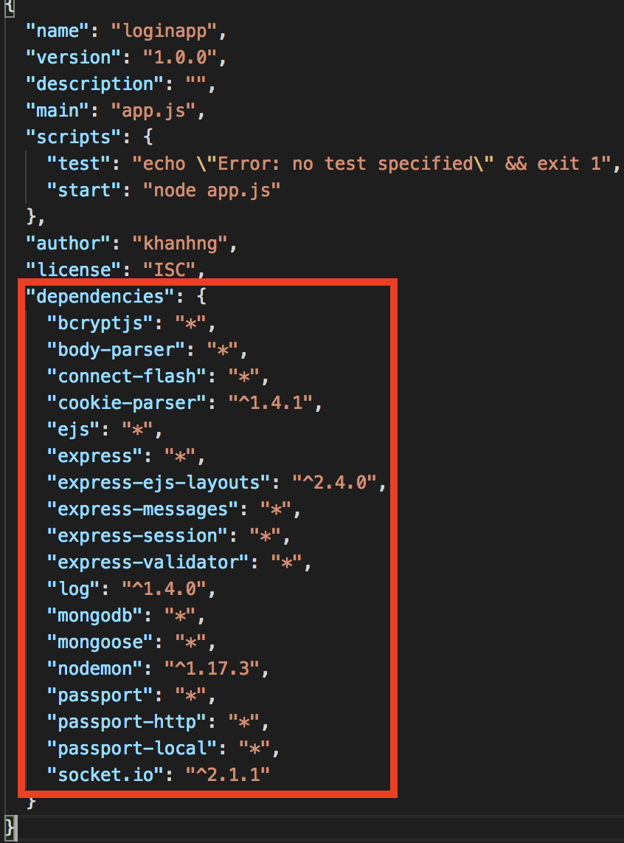

*Figure 25 – NodeJS Package*

* + 1. **MongoDB**

In order to install MongoDB on MacOS, the recommendation choice is to install through HomeBrew. First, go to HomeBrew website <https://brew.sh> to get the script:

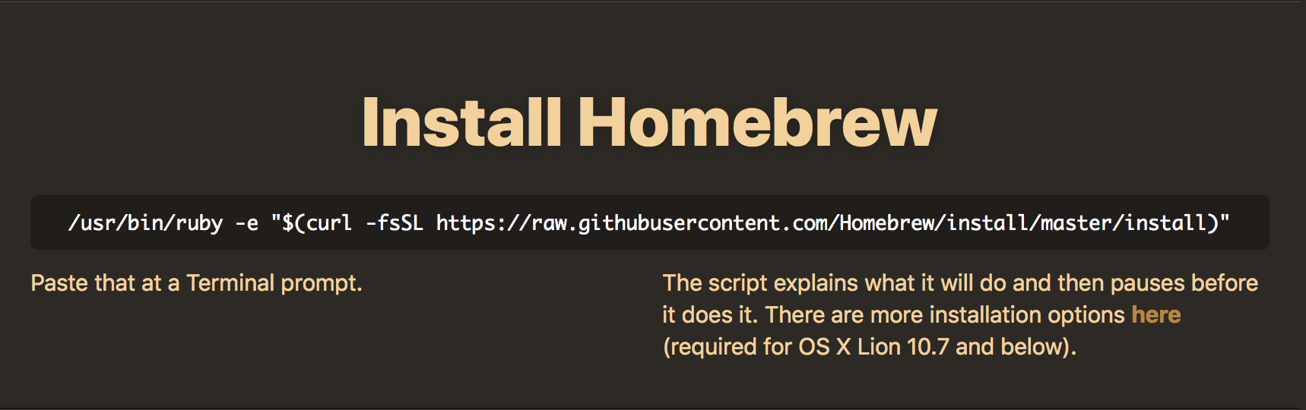

*Figure 26 – Homebrew*

Copy the script and paste to Terminal prompt and if press RETURN(Enter) button to continue the process. The password of your computer is required to continue the installation after pressing Return.

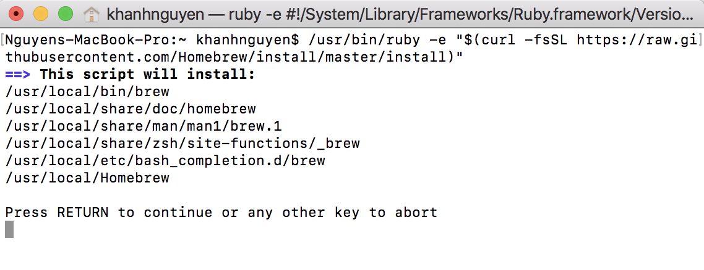

*Figure 27 – Installation of Homebrew*

The next step is following the instruction from MongoDB documentation page https://docs.mongodb.com/manual/tutorial/install-mongodb-on-os-x/. Update the brew after the above process complete by using “brew update”. If it is uptodate then go to next step which is install MongoDB with “brew install mongodb”.

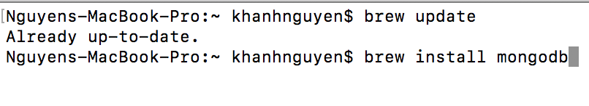

*Figure 28 – Installation of Mongodb*

The process is very quickly so it will take from 1 to 2 minutes. In order to run MongoDB, user must use root privilege to run it. By typing “sudo mkdir -p /data/db” , this step will create the directory to which the mongod process will write data.

To test whether the installation of MongoDB is finished or not, go to Terminal and type “sudo mongod” to run the server of MongoDB.

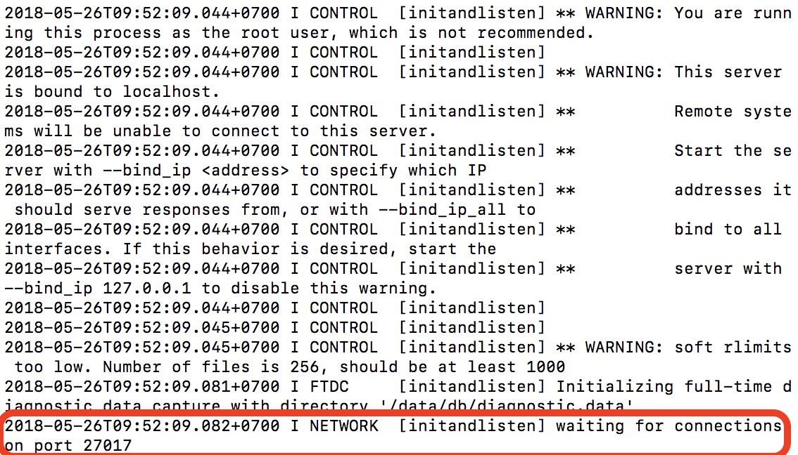

*Figure 29 – Run Mongodb*

Now it is running on port 27017 which mean the installation is successful. Next step, go to new terminal and type “mongo” which will start MongoDB database. And now user can have some command to check such as “show dbs” like the picture below to show all the database that existed in local machine.

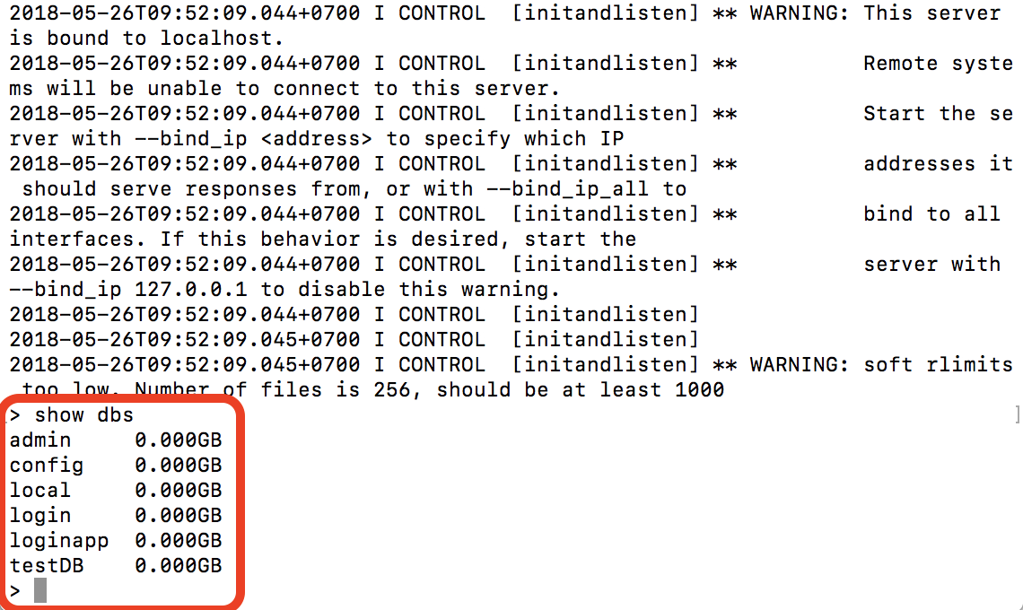

*Figure 30 – Testing Mongodb*

* 1. **Results**

After researching and testing of NodeJS language, the result of communicating directly from client and server is very fast as well as how user experience the website. There are many techinique that have been applied and tested to achive final goal.

* + 1. **Streaming 1-many.**

In order to perform live stream for teacher to live their lesson when the class started. NodeJS socket-io package is the most suitable for this requirement. Socket-io is featuring the fastest and the most reliable real-time engine for many purposes such as: Instant messaging and chat, real-time analytics, binary streaming, etc. Socket-io works on every platform, browser or device, focusing equally on reliability and speed.

Live Stream system is used for teacher to stream (only 1 way streaming and user with roll teacher can access to stream button). Student can watch stream of course that they registered.

When teacher want to stream their lesson, browser will ask permission for using camera.

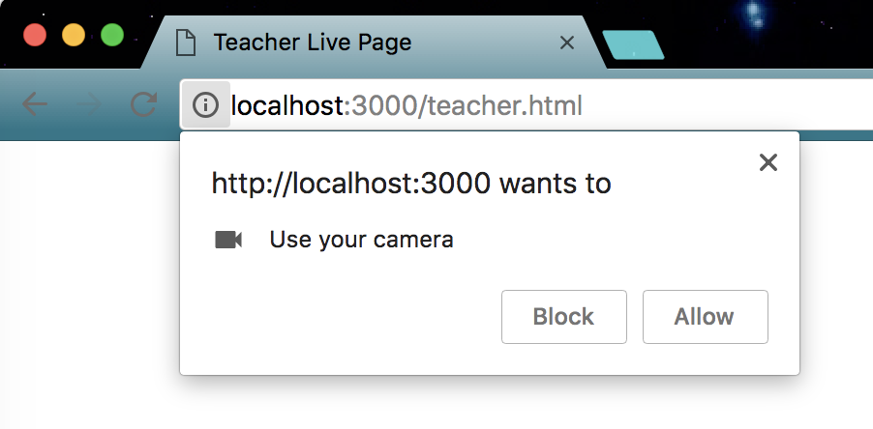

*Figure 31 – Live Stream*

To distinguish between who is streaming and watching by watching the title of page. There is a circle in the end of the title to show live stream event and student only can watch the stream.

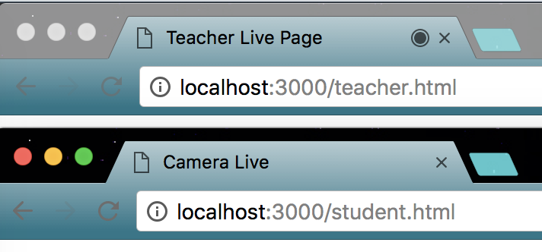

*Figure 32 – Teacher and Student Interface*

* + 1. **Push New Notifications**

Teacher will have some notification to announce to student and student will receive the information before class.

Both Student and Teacher have to register for an account, this system using roll to distinguish between student and teacher (student have roll user and teacher have roll teacher).

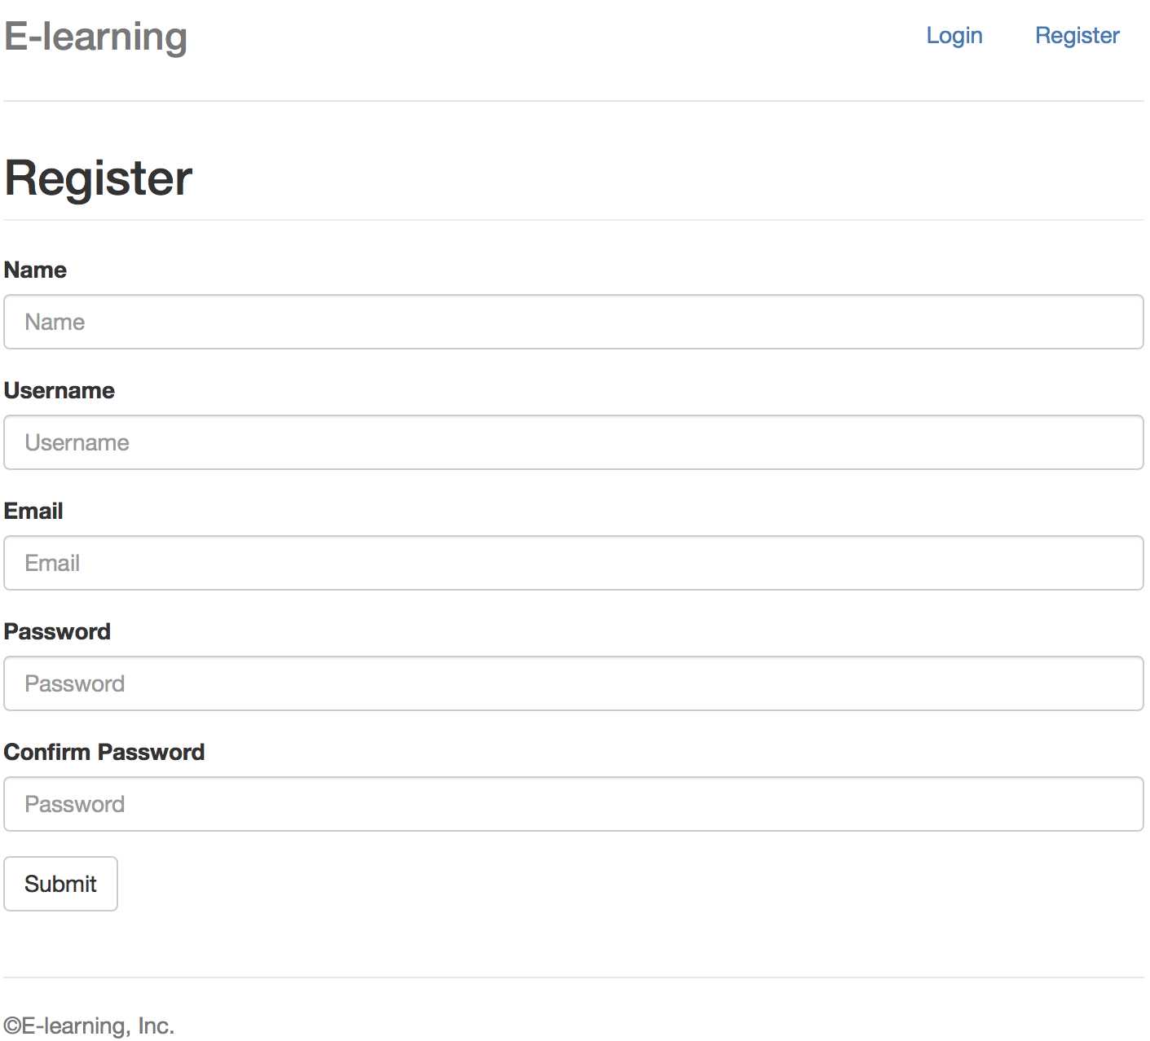

*Figure 33 – Register Interface*

There is a function for teacher have their own view and student have their own view. It will check if user roll equal to “admin” then redirect to admin view else redirect to student view.

Teacher view have list of course (course list only can view but not can create, course is the same for every semester). Teacher can create class and view list of students of that class.

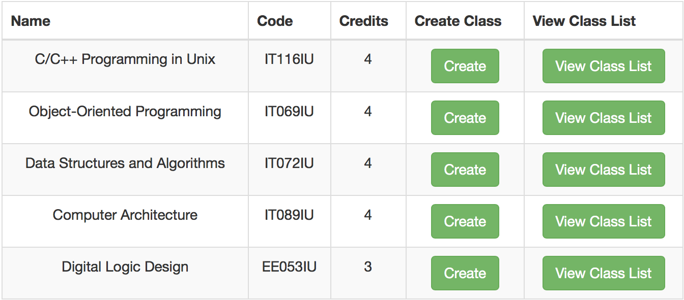

*Figure 34 – View Class list*

Teacher can add information about the class to database. When the class is full or started, teacher can live their lesson through live Stream function for teacher.

Teacher is allowed to stream lesson when pressing Start button and Student can view the lesson.

The class can show to student and teacher but have different view. Teacher can view list of students of that class.

Last function of teacher is send notification to all user of that class.

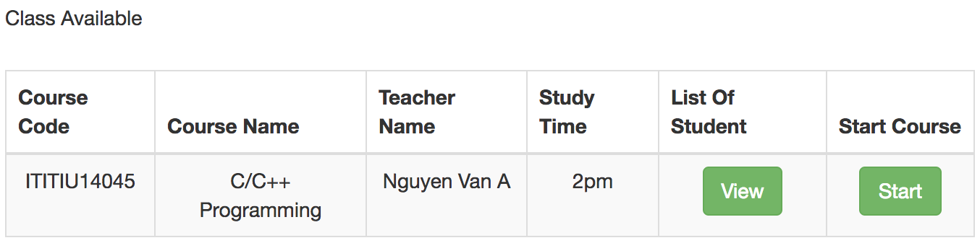

*Figure 35 – Class Available*

This is a view of all student in class.

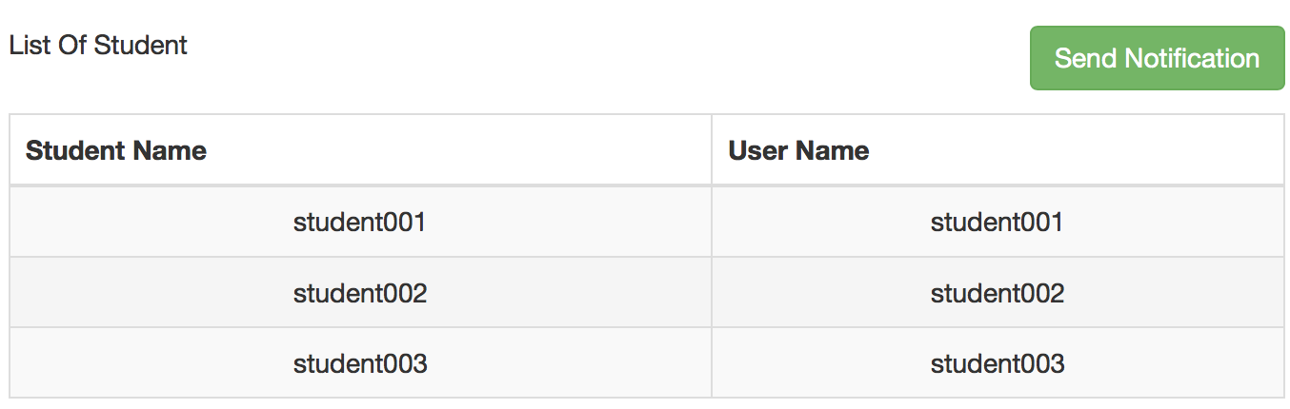

*Figure 36 – List Of Student*

Student now only able to view new notification from teacher and list of class that teacher creates. When teacher live, student can watch the lesson.

This allow student to view when teacher is not live yet, join the room first but not with streaming function.

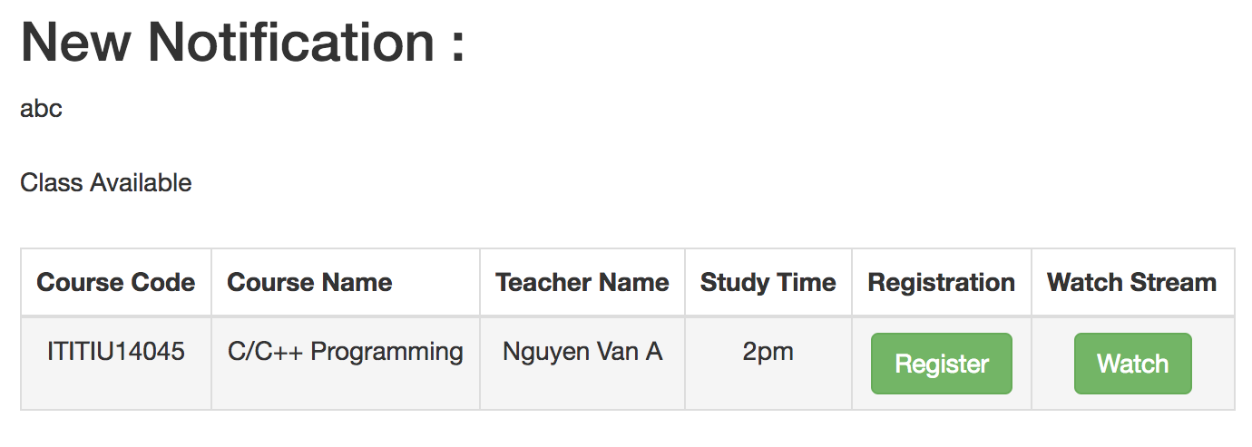

*Figure 37 – Student Interface*

### Chat

Chat system was first developed with the purpose of allowing student ti interact with teacher whenever they have question or anything not clear about the lesson. Chat system is based on socket.io in NodeJS to create a real time communication between client and server. Using this just like implement a pulling data by Javascript depending on developer set (for example every 3 seconds the data will be automatically pulled so the data in website will be updated immediately).

When user connected to e-learning system, it will regonize username and show to other users when they chat something like figure 38. Like I said above socket.io using real time data pulling so the posting action takes about 3 seconds to appear the message in another user interface.

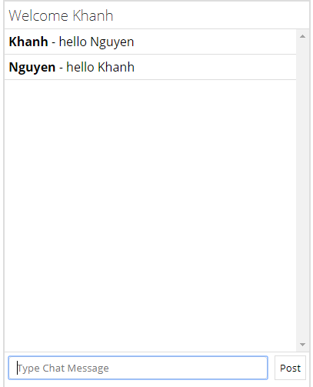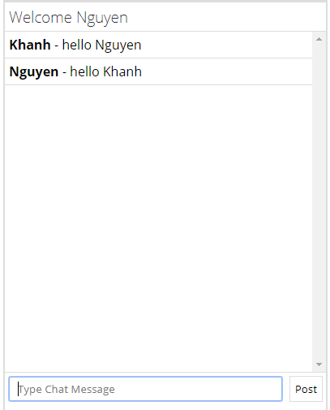

*Figure 38: User interfaces*

Futhermore, every action that users do will be handled by server, by doing this the data will be pulled at real time. For example, the “new message” action will be executed when client emits.

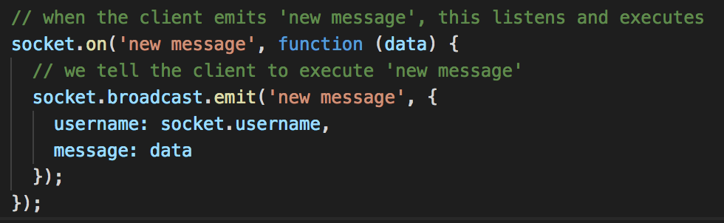

*Figure 39: Socket new message*

# CHAPTER 5

# CONCLUSION AND FUTURE WORK

## Conclusion

The main objective of this project is to create an e-learning application that can help students in their study. With the support of socket as well as some package in NodeJS, I can create a live streaming for teacher to teach the lesson directly to student without using another third software. In this project, I was able to create some simple function like login, logout, register course, etc. There are lots of problems to considered during the development later but in this project, the main thing is to design a JSON database that can control the whole system, JSON database can only link to another table by using id field which is created by MongoDB. This system is not difficult to build, this is a more advance system compare to the project in web application subjects so it takes more time to research and test whether it work or not in the real life.

## Future Work

In the future, there are more functions to be complete in order to fulfill the requirement of an e-learning website. First, I will improve the UI of the website by using AngularJS rather than only using basic html, css and also include Bootstrap so that it can become a responsive website which is a basic requirement of web application nowsaday. And finally, the code will be optimized in near future to increase the speed of the system and the data transfer is real time transfer without reloading page. At present, there are not much time to combine all lack of requirements but it will be completed in near future.

# REFERENCES

[1]: JavaScript stream.

<https://www.sitepoint.com/stream-your-webcam-to-a-browser-in-javascript/>

[2]: Media Stream API.

<https://developer.mozilla.org/en-US/docs/Web/API/Media_Streams_API/Constraints>

[3]: Live Stream Website.

<https://www.romexsoft.com/blog/live-streaming-website/>

[4]: How to create live stream platform.

<https://www.wowza.com/community/questions/6439/a-dummys-guide-to-creating-a-live-streaming-platfo.html>

[5]: Kurento in NodeJS

<https://groups.google.com/forum/#!topic/kurento/yXnWUlJrnEM>

[6]: Webrtc in NodeJS

<https://stackoverflow.com/questions/21402840/webrtc-for-one-to-many-broadcast-using-node-js>

[7]: NodeJS Documents

<https://nodejs.org/en/docs/>

[8]: MongoDB Documents

<https://docs.mongodb.com>